Pre-Reading

Mom gives up
Most of the words in this packet should be review, but there are a few new ones. The first character to look at is 待 (dai1), this means to stay, I remember this character by looking at the left side, it is the two person radical, I think of one person waiting for another person, or one person staying in a place for someone else. The second word 小时 (xiao3shi2) literally means small time, but we know it as hour. The next character 看 is see, but in this story it is used in the context of “I want to see if my friend came.” It is important to know that 看 (kan4) also has the meaning of to check or verify. The next word should also be review 已经 (yi3jing1) which means already. The next word 了没有 is a colloquial form of 吗. But is usually used to ask if an action has been completed. For example 你去了吗？Did you go? Can also be said like this 你去了没有？ Both are ok. The next word 我妈, my mother, just remember that the 的 for possession can be dropped in spoken Chinese and that 妈妈 sometimes the second 妈 is dropped when the speaker is in a hurry. 觉得 (jue2de) is again review it means to think. 肯定 (ken3ding4) simply means for sure. The next phrase 找不到, you know that 到also means to complete an action or a goal so 找到 means to find, but 找不到 must mean not to find. IF we say 我听不到 it means that I can’t hear something that I’m trying to listen to, in contrast to 听不见 I can’t hear something, but I’m not necessarily trying to hear it. The last word 想 you have already seen many times, but remember it can be mean to think and to want.

Vocabulary/Writing

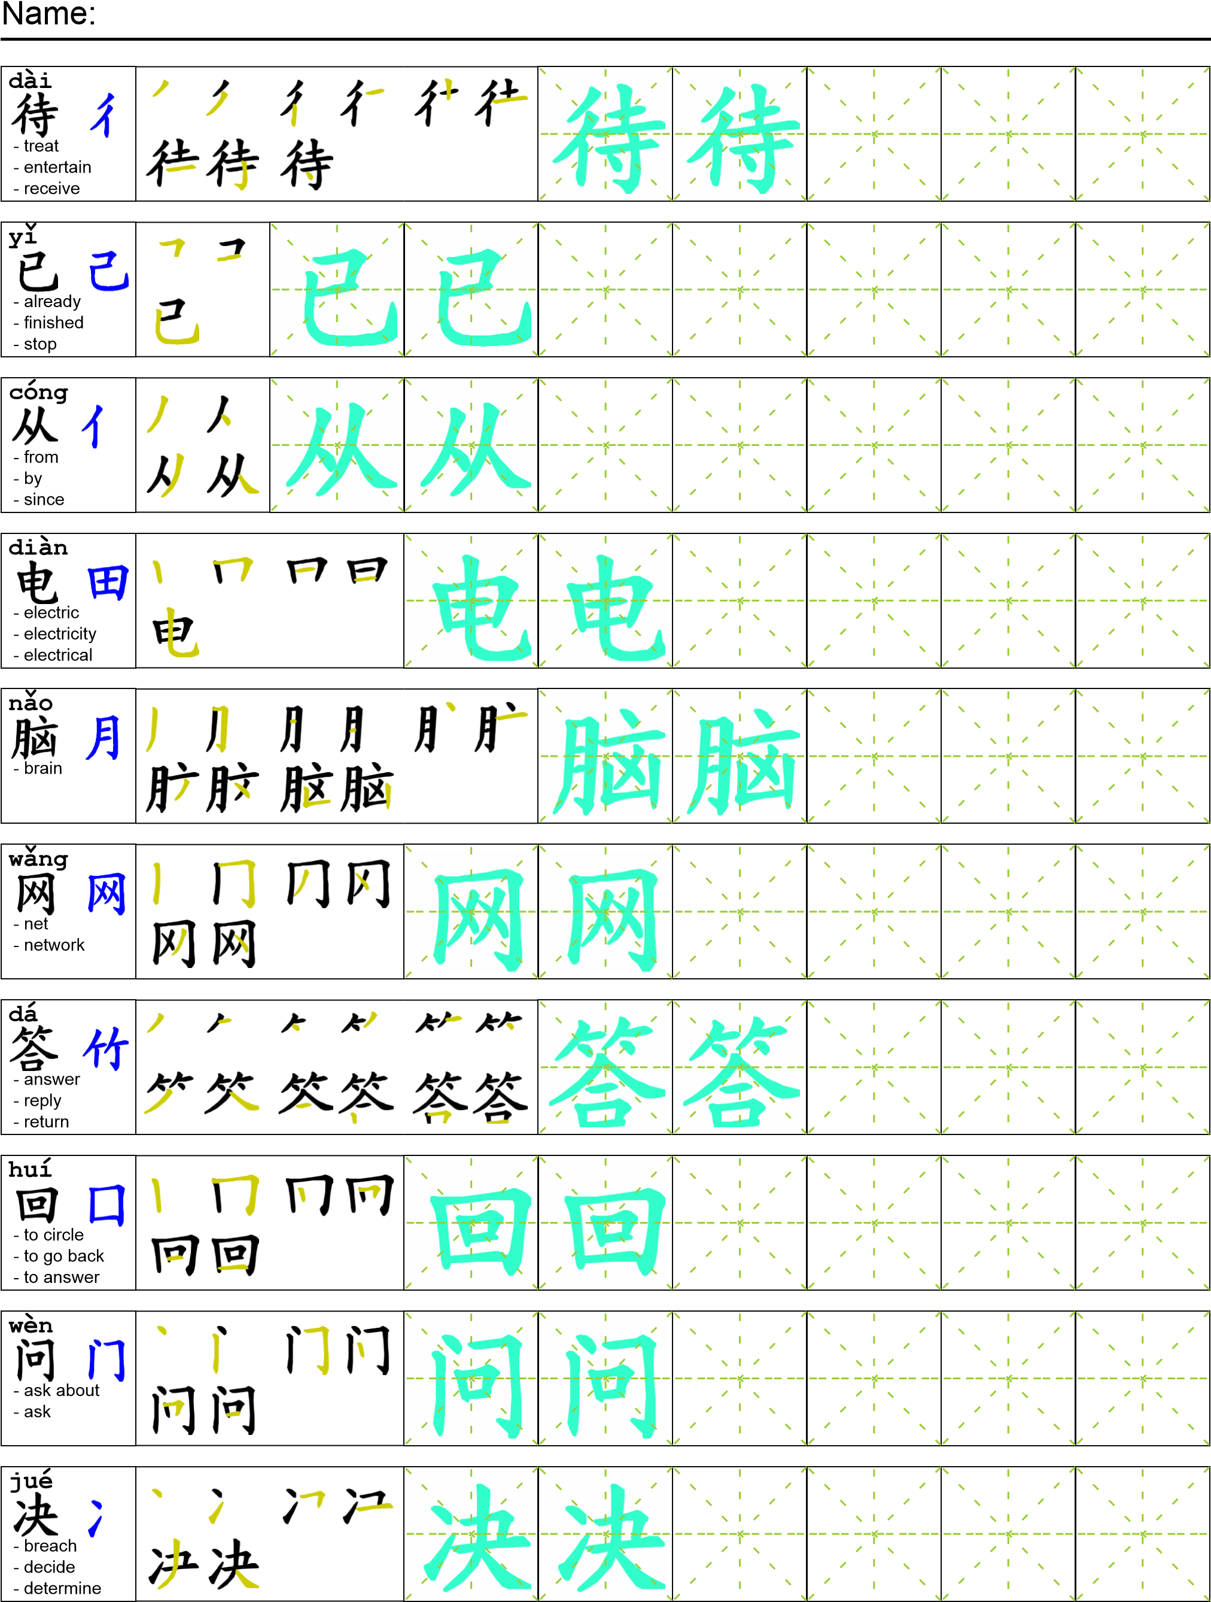
Reading

我在公园待了一个小时还没想到小偷是谁。 我决定去找我妈妈看她发现了什么。我到家的时候我妈妈已经从食堂回来了。 她正在用电脑上网。 我问她“你发现小偷是谁了没有？”我妈回答“还没有，我觉得我们肯定找不到他了，最好还是别想了。”
Task Completion

Once all tasks are complete turn the assignment in to collect the points for the project.
Task 1: Trace the vocabulary and copy the text into your notebook.

Task 2: Answer Comprehension Questions.

Task 3: Write the Pinyin for the Reading.

Task 4: Translate the Reading into English.

Task 5: Record yourself reading the passage.

Comprehension Questions
- Give me three examples of an incomplete action using 不到and tell me how to translate them into English.
- Write three sentences in Chinese using the word 待.
- What advice does the mother give at the end of this packet?

